|  |  |
| --- | --- |
| **Item No:** 3.1 |  |
| **Title:** Deferred Item - Planning Proposal 84/2015 for land on the corner of Collingwood Drive and Matcham Road, Matcham |  |
| **Department:** Innovation and Futures |  |
| 19 October 2020 Extraordinary Council Meeting |  |

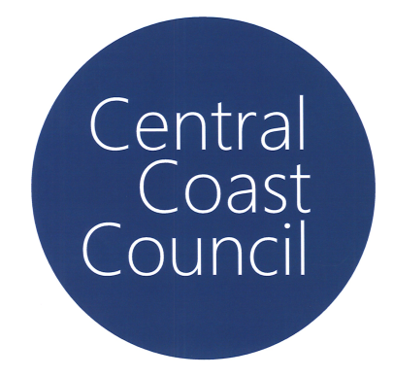Reference: F2020/00039 - D14238124

Author: Bruce Ronan, Town Planner

Scott Duncan, Section Manager, Land Use and Policy

Manager: Shari Driver, Unit Manager, Strategic Planning

Executive: Ricardo Martello, Executive Manager Innovation and Futures

|  |
| --- |
| **Report Purpose**  At its meeting held 12 October 2020, the Council resolved, in part as follows:  *963/20 That Council defer all items with the exception of the following to an Extraordinary meeting to be conducted remotely on Monday, 19 October 2020 at 6.30pm:*  *- Item 1.3 – Notice of Intention to Deal with Matters in Confidential Session*  *- Item 1.4 - Mayoral Minute – Staff Matter*  *- Item 1.5 - Mayoral Minute – Establishment of a Finance Committee to Oversee Council’s Forensic Financial Audit and 100-Day Action Plan to Recovery*  *- Item 3.7 – Council Representative for Hunter and Central Regional Planning Panel (Late Report)*  *- Item 3.8 – Serious Financial Situation (Late Report)*  *- Notice of Motion 6.2 – Collapse of Confidence in Council’s Internal Controls and Financial Management* |
| **Report Purpose**  The purpose of this report is for Council to consider a Planning Proposal which seeks to rezone Lots 11, 12 and 13 DP 576336 and Lot 2 DP 561283 on the corner of Collingwood Drive and Matcham Road, Matcham from 7(a) Conservation and Scenic Protection (Conservation) under *Interim Development Order No 122 – Gosford* to E4 Environmental Living under the *Central Coast Local Environmental Plan* when it comes into effect.  The Minimum Lot Size Map in the *Central Coast Local Environmental Plan* is to be amended to show the land having a minimum lot size of 1 Hectare.  This report provides an overview of the outcomes of State agency and community consultation in respect of the planning proposal.  The report recommends that Council finalise the planning proposal through an amendment to the future Central Coast Local Environmental Plan when it comes into effect. |

**Recommendation**

1. ***That Council support the Planning Proposal as exhibited.***
2. ***That Council request the Chief Executive Officer to exercise delegation issued by the Department of Planning, Industry and Environment (8 August 2017) for PP/84/2015 and proceed with the steps for drafting and making of the amendment to the Central Coast Local Environmental Plan when it comes into effect.***
3. ***That Council request the Chief Executive Officer to undertake all necessary action to finalise the Planning Agreements relating to the four lots.***

***4 That Council advise all those who made a public submission of the decision.***

**Background**

On 26 April 2017, the Council (Administrator) resolved that Council prepare a planning proposal to amend Interim Development Order No 122 (IDO 122), to rezone the land from 7(a) Conservation and Scenic Protection (Conservation) to 7(c2) Conservation and Scenic Protection (Scenic Protection – Rural Small Holdings).

This proposal sought to utilise the provisions of Clause 18(4) of IDO 122 (the “bonus lot” provision), to enable subdivision to a minimum of 1 Ha, supported by a contribution to Council towards the purchase or embellishment of land identified in Council’s Coastal Open Space System (COSS) at the Development Application stage.

The Planning Proposal was not able to be publicly exhibited prior to the exhibition of the draft Central Coast Local Environmental Plan (CCLEP) which began on 9 December 2018. As the draft CCLEP proposed to phase out the “bonus lot” provisions of IDO 122 relied on by this proposal, there was no strategic basis to amend a planning instrument that that was proposed to be repealed. Due to the work already undertaken by the applicant, a solution to progress the planning proposal was required whilst achieving the outcome intended under the original resolution.

Therefore, a report was submitted to Council proposing to amend the Planning Proposal to zone the land E4 Environmental Living under the CCLEP and enter a Planning Agreement with the owners to pay a contribution equivalent to that which would have been required under IDO 122.

At the Ordinary meeting held on 11 March 2019, Council resolved:

*162/19 That* *Council support an amended Planning Proposal to rezone:*

*a) Lot 11 DP 576336 No 24 Collingwood Drive, Matcham;*

*b) Lot 12 DP 576336* *No 14* *Collingwood Drive, Matcham;*

*c) Lot 2 DP 561283 No 2 Collingwood Drive, Matcham; and*

*d) Lot 13 DP 576336 No 107 Matcham Road, Matcham*

*from 7(a) Conservation and Scenic Protection (Conservation) under Interim Development Order No 122 to E4 Environmental Living Zone as defined in the draft Central Coast Local Environmental Plan with appropriate provisions to permit subdivision to a minimum lot size of no more than 1 Ha.*

*163/19 That Council submit a revised Planning Proposal to the Minister for Planning in accordance with Section 3.35(2) of the Environmental Planning and Assessment Act 1979, requesting an amended Gateway Determination, pursuant to Section 3.34 of the Environmental Planning and Assessment Act 1979.*

*164/19 That Council request delegation for Council to finalise and make the draft Local Environmental Plan, pursuant to Section 3.36 of the Environmental Planning and Assessment Act 1979.*

*165/19 That Council enter into a Voluntary Planning Agreement with the landowners to pay a contribution to purchase conservation lands which is equivalent to that required under Interim Development Order No 122- Gosford.*

*166/19 That Council undertakes community and public authority consultation in accordance with the Gateway Determination requirement.*

*167/19 That Council considers a further report on the results of the public authority and community consultation.*

A Gateway Determination Alteration was issued by the Department of Planning, Industry and Environment (DPIE) on 12 April 2019. On 18 December 2019, this Gateway Determination was subsequently extended to 4 November 2020.

**The Site**

The subject site (Figure 1) comprises four lots on the corner of Matcham Road and Collingwood Drive, Matcham. The site comprises:

* Lot 2 DP 561283, 2 Collingwood Drive
* Lot 12 DP 576336, 14 Collingwood Drive
* Lot 11 DP 576336, 24 Collingwood Drive
* Lot 13 DP 576336, 107 Matcham Road

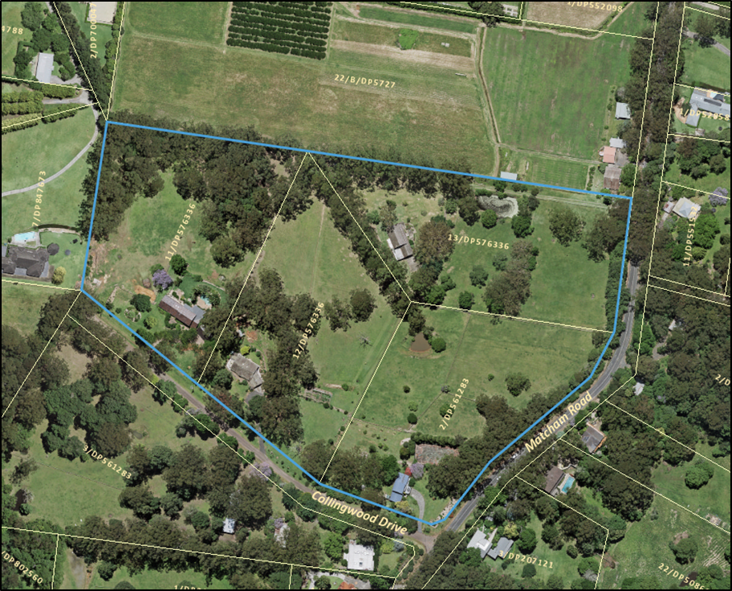

***Figure 1:*** *Subject Site Aerial Locality/Context Plan*

Each lot within the subject site is approximately 2 Ha in area with the subject site comprising a total area of 8.092 Ha.

The subject site contains a mix of cleared and vegetated areas. The site occupies a ridge and side slopes (some parts having slopes over 20%) that runs in an east-west direction. All four land parcels contain one dwelling-house and associated structures.

The subject site is zoned 7(a) Conservation and Scenic Protection (Conservation) under *Interim Development Order No 122* (IDO 122). The minimum lot size applicable to the subject lots is 40 Ha.

Land adjoining the site on the southern side of Collingwood Drive and on the eastern side of Matcham Road is similarly zoned 7(a) Conservation and Scenic Protection (Conservation) zone. Land north and west of the site is zoned 7(c2) Conservation and Scenic Protection (Rural Small Holdings) (Figure 2).

Of the 31 lots in the immediate vicinity of the subject land (i.e. within 200m), 16 lots are 1.0 – 1.49 Ha in area and 7 lots are less than 1.0 Ha in area.

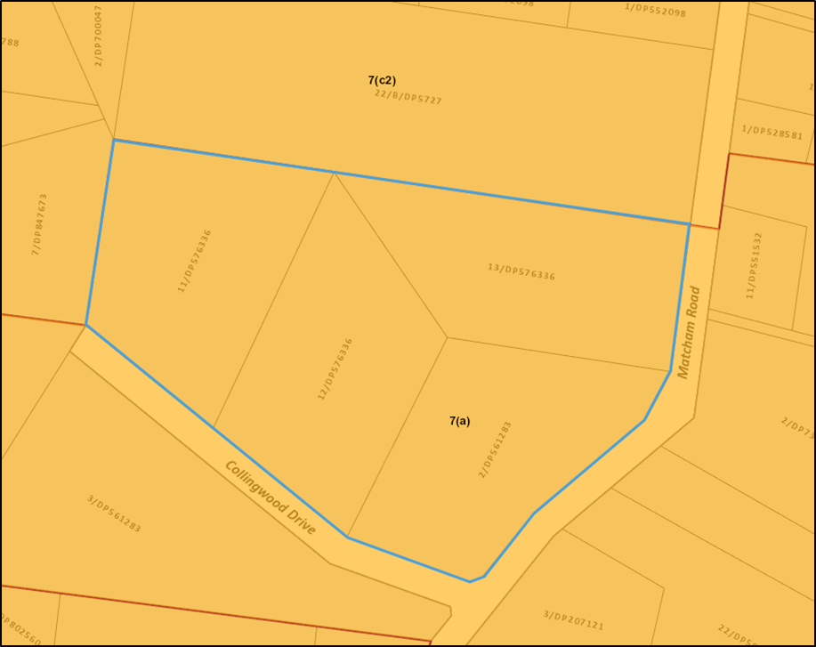

***Figure 2:*** *Existing Zoning*

**The Proposal**

The objective of this proposal is to establish an appropriate zoning of the land considering its characteristics to enable each of the 2 Ha lots to be subdivided into 2 x 1 Ha lots.

The minimum lot size under the 7(a) Conservation and Scenic Protection (Conservation) zone is 40 Ha so any further subdivision is prohibited. The original planning proposal considered by Council in 2017 sought to zone the land to 7(c2) Conservation and Scenic Protection (Scenic Protection – Rural Small Holdings) which would enable each lot to be subdivided into 1 Ha allotments, via a development application, under the “bonus lot” provisions within clause 18(4)(b) of IDO 122.

The standard Instrument LEP and hence the draft Central Coast Local Environmental Plan (CCLEP) does not provide for “bonus lot” provisions. Given that the draft CCLEP has finished public exhibition, it was considered likely that the provisions of IDO 122 originally relied on by this proposal would not be in effect when this planning proposal was finalised. Furthermore, the DPIE is no longer amending old planning instruments such as IDOs. Consequently, any rezoning of land would have to be to a zone specified in the Standard Instrument LEP.

Under the draft CCLEP, as exhibited, the subject land is proposed to be zoned E4 Environmental Living (Figure 3). Hence the Planning Proposal seeks to rezone the land to E4 Environmental Living which is consistent with what was publicly exhibited with the draft CCLEP.

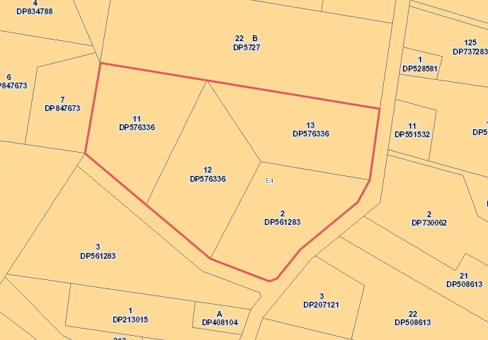

***Figure 3:*** *Proposed zoning under CCLEP*

It should be noted that the land cannot be zoned E4 Environmental Living under *Gosford Local Environmental Plan 2014* (GLEP 2014) as this zone permits such uses as pubs, restaurants and tourist and visitor accommodation which are incompatible with the character of this locality. The zoning of the land to E3 Environmental Management under the GLEP 2014 was also considered but was considered inconsistent with the zoning framework proposed in the draft CCLEP. Therefore, the finalisation of the proposed zoning under this Planning Proposal would have to await the implementation of the draft CCLEP.

The proposed minimum lot size for the E4 Environmental Living zone under the draft CCLEP is 2 Ha which will not permit further subdivision. Therefore, in order to permit a 1 Ha lot size, the subject land is proposed to be mapped accordingly on the Minimum Lot Size Map.

In order to achieve the smaller minimum lot size of 1 Ha intended by the proposal, and to ensure that Council does not lose an opportunity to acquire or embellish COSS land, the owners have agreed to enter a Planning Agreement to pay an amount to Council equivalent to the amount that would have been required under IDO 122. The draft Planning Agreement requires the payment of this sum prior to the issue of a subdivision certificate for the subdivision of the land.

The contribution for the subdivision of each of the four lots into two lots under the bonus lot provisions would be $92,688.75, or $370,755 for the entire development. These funds would be used for land purchase and/or embellishment of land in the Coastal Open Space System (COSS).

**Consultation**

The Planning Proposal and draft Planning Agreements were publicly exhibited from 5 February 2020 to 3 March 2020. Exhibition of the proposal was undertaken in accordance with the DPIE’s *A Guide to Preparing Local Environmental Plans* (August 2016) and the gateway determination.

**Community Consultation**

One submission was received during the exhibition period. The matters raised by the submission are summarised and responded to below.

**1 The Council report dealing with the exhibited Planning Proposal acknowledges that the proposed 1 ha lot size is consistent with the character of the area. Yet the CCLEP proposes a 2 ha minimum lot size for the remaining E4 land within the locality.**

*Comment*

The owners of the subject four lots lodged a Planning Proposal in 2015 prior to the amalgamation of the former Gosford City Council (fGCC) and former Wyong Shire Council (fWSC). Lodgement of the Planning Proposal occurred prior to the Council resolution to commence work on the draft CCLEP.

This rezoning is supported by site specific studies which confirms that the site is capable and suitable to be rezoned into one-hectare allotments. As this was a landowner-initiated Planning Proposal it was possible to examine site suitability considerations at a finer level than the draft CCLEP. Additionally, this proposal was an older rezoning proposal and involves significant community benefit outcomes which provides a funding contribution to purchase COSS lands.

The draft CCLEP is only the first step in the production of one LEP for the Central Coast, which requires the completion of a program of strategic planning strategies which will be implemented in phased LEP amendments. This is likely to mean that land use zones in ‘deferred lands’ will need to be reviewed following the finalisation of the draft CCLEP. Council staff will also commence work on developing a new conservation incentive clause policy in the future, as it is an action recommended in Council’s draft Biodiversity Strategy. These actions may lead to policy changes in the future which could create similar opportunities for other landowners. However, this needs to be looked at as part of a broader package of strategic work which is proposed to occur after the draft CCLEP is finalised.

**2 There are a total of eight lots in the Matcham valley currently zoned 7(a) under IDO 122 to E4 under CCLEP. Four of these lots form the subject Planning Proposal. There appears no parity for the owners impacted by these strategic planning decisions.**

*Comment*

In the suburb of Matcham there are 31 lots that are wholly zoned 7(a) Conservation under IDO 122 which are proposed to be zoned E4 Environmental Living under the draft CCLEP. Four of these lots are the subject of this Planning Proposal. There are unique circumstances on this site, as the subject Planning Proposal was lodged with Council prior to the Council amalgamation and the preparation of the CCLEP. Other owners’ who have expressed an interest in achieving similar development proposals do not have a Planning Proposal with Council and even if such an application was made, it would be assessed under the current strategic planning considerations and would need to consider the status of the draft CCLEP.

**3 One must wonder why a 1 ha minimum lot size was not just recommended for adoption in the E4 zone as part of the CCLEP, rather than defer the lot size issue to the Comprehensive LEP. Particularly in light of the inconsistency created by the current Planning Proposal.**

*Comment*

The draft CCLEP is generally a consolidation of the Gosford and Wyong LEPs, so a variation to the minimum lot size in the E4 zone, as suggested, would not constitute a consolidation issue. It is a strategic planning matter that will require additional investigation to justify what land has any further subdivision potential and to determine the suitable planning mechanism required for this to operate.

The introduction of a similar conservation incentive clause (to replace the existing bonus lot provision clause) across the Central Coast will be further considered as part of a separate project following the finalisation of the draft CCLEP. This might provide opportunities for similar proposals; however, it needs to be undertaken as part of a broader strategic package of work to examine how it might be applied and to what land.

**4 Other landowners should have been given the opportunity to enter a Planning Agreement as part of the considerations of the draft CCLEP and a 1 ha minimum lot size applied to the locality. The owner of 200 Matcham Road seeks consideration of this issue as part of the current Planning Proposal.**

*Comment*

The subject Planning Proposal relates to four lots on the corner of Collingwood Drive and Matcham Road. Additional land cannot be included in this Planning Proposal as the necessary studies have not been carried out and such an amendment would require the Planning Proposal process to begin again.

**Government Agency Consultation**

*Rural Fire Service*

The gateway determination outlined requirements for government agency consultation, specifically with the NSW Rural Fire Service (RFS). The RFS advised:

*Based on an assessment of the information provided, NSW RFS raises no objections to the proposal subject to a requirement that the future subdivision of the land complies with Planning for Bushfire Protection, 2006 (or any subsequent version).*

**Internal Consultation**

Internal consultation for the current Planning Proposal has been undertaken as summarised below.

*Environmental Health*

There is sufficient land available on all 4 lots to accommodate wastewater disposal from both the existing dwellings and any new dwellings. The Environmental Health Team therefore has no objections to the proposal, subject to Wastewater Management Plans being submitted for each property at subdivision stage.

The Preliminary Environmental Investigation concludes the site is suitable for the proposed use, from a contamination perspective. There is no objection to the planning proposal on this issue.

*Environmental Strategies*

The Planning Proposal has sufficiently avoided impacts to biodiversity values of the site and is not likely to have a significant impact on any threatened species, population or ecological communities or their habitats.

**Outcomes of Consultation**

Having regard for the public and state government submissions the proposal has satisfied relevant statutory requirements relating to agency and community consultation.

**Councillor Site Inspection**

A site inspection was undertaken on 3 August 2020 which was attended by Council staff and Councillors. The summary of the issues raised is outlined in Attachment 2.

**Assessment**

The rezoning of the subject land to E4 Environmental Living under the draft CCLEP has strategic merit on the basis that:

* The existing lots do not satisfy the objectives of the current 7(a) Conservation and Scenic Protection (Conservation) land zoning;
* The existing lots achieve the zone objectives of the E4 Environmental Living under the draft consolidated CCLEP as the lots reflect the rural residential character that supports the overall aesthetic and scenic value of the Matcham area;
* Adjoining land was nominated to be zoned E4 Environmental Living in the draft CCLEP, however these lands are proposed (subject to Council endorsement) to be subject to a LGA-wide environmental lands review;
* The DCP provisions would require building envelopes to be located in cleared areas, thus not significantly impacting on the existing vegetation on each of the lots.

The draft CCLEP is based on the Standard Instrument LEP template. The Standard Instrument LEP does not include or enable bonus lot provisions such as those which exist under IDO 122.

Under the draft CCLEP the subject land is proposed to be rezoned from 7(a) to E4 Environmental Living. The E4 zone was exhibited for this site as part of the draft CCLEP from 6 December 2018 – 28 February 2019. A report on the outcomes of the public exhibition process for the draft CCLEP was considered by Council on 9 March 2020 but finalisation of the CCLEP was deferred for revision and reconsideration. In response to public submissions, one of the recommendations within the 9 March 2020 report is to further refine the criteria being applied to the zoning of Deferred Matters lands currently subject to IDO 122 and reconsider these lands as part of an LGA wide Environmental Lands Review.

Despite the current status of the draft CCLEP/DCP project, this site has been considered, independently of the draft CCLEP, as a separate planning proposal, and the proposed zoning is considered to be best defined by the E4 Environmental Living zoning. This will mean that even if Council resolves to proceed with the subject Planning Proposal, the remaining statutory process is unable to be completed until the draft CCLEP has been adopted by Council and notified.

The introduction of a similar conservation incentive clause (to replace the existing bonus lot provision clause) across the Central Coast will be further considered as part of a separate project following the finalisation of the draft CCLEP. The proposal will also make a contribution towards the COSS through a Planning Agreement mechanism. Such an outcome is consistent with Council’s policies relating to the acquisition of COSS land in the former Gosford City Council and therefore will result in a public benefit. Consequently, the Planning Proposal, is suitable for support.

**Statutory Compliance and Strategic Justification**

The planning proposal has been assessed having regard for all State Environmental Planning Policies, Ministerial Directions and the relevant guidelines set out within the Central Coast Regional Plan 2036 (CCRP). The proposal is considered to be consistent with the CRRP and is suitable for forwarding to the Department of Planning, Industry and Environment for finalisation. The CCRP 2036 and the Interim LSPS identifies key actions for rural land and environmental land that will inform the future considerations of planning proposals on rural land.

**Social Impacts**

The planning proposal will result in the development of additional housing and the improvement of housing choice which is consistent with the strategic directions of the CCRP.

**Environmental Considerations**

There are no environmental impacts as discussed previously in this report.

**Interim Local Strategic Planning Statement**

The proposal has been assessed having regard for the Growth Strategies defined by the Interim Local Strategic Planning Statement (LSPS). The proposal is not inconsistent with the growth strategies relating to “refining the urban edge” and key planning priorities relating to the Environment, and Agricultural and Rural Land.

A Rural Lands Study and Strategy are under preparation together with a suite of planning consolidation plans including the Central Coast LEP, DCP and Development Contributions Plans. These will guide future outcomes to be consistent with the Interim LSPS.

**Link to Community Strategic Plan**

Theme 3: Green

|  |
| --- |
| Goal F: Cherished and protected natural beauty |
| G-F1: Protect our rich environmental heritage by conserving beaches, waterways, bushland, wildlife corridors and inland areas, and the diversity of local native species. |

G-F2: Promote greening and the wellbeing of communities through the protection of local bushland, urban trees, and expansion of the Coastal Open Space System (COSS).

**Risk Management**

There have been no risks identified to the natural and built environment if this planning proposal is supported by Council as previously discussed in this report.

**Delegation**

Council has been issued with the delegations of the Minister to make amending Local Environmental Plans (LEPs).

The altered gateway determination issued on 8 August 2017 provides the Council’s Chief Executive Officer, the appropriate delegations under Section 59 of the *Environmental Planning and Assessment Act, 1979* (EP&A Act) to make this plan. Council has been issued with the delegation of the Minister to make the amending Local Environmental Plan. Council has advised the DPIE that Council’s delegate for this function is the CEO, Gary Murphy.

**Conclusion**

The proposed amendment to the Planning Proposal to zone the land E4 Environmental Living under the draft CCLEP when it comes into effect, is considered to have strategic merit.

It is recommended that the Council support the progress of the Planning Proposal and undertake the necessary steps to finalise the local environmental plan in accordance with the statutory process.

**Attachments**

|  |  |  |  |
| --- | --- | --- | --- |
| **1** | Proposal Summary |  | D13413281 |
| **2** | Councillor Site Inspection Summary |  | D14155829 |